Assignment 1

Assignment 1a

Japan is now producing more adult diapers than infant ones. The number of kids in Japan has fallen for the 37th straight year. And unlike other countries, it has not been able to replace its population numbers through immigrant workers. There will be labor shortages and not enough money to fund the safety-net programs. Now, Japan has introduced two solutions. First, a financial incentive. Some local governments in Japan have offered couples money to have babies, with the money increasing with each additional child being born. This actually worked for one year in 2014 in this town called Ama. It actually raised the birth rate from about 1.66 kids per woman to 1.8. But it did not gain traction across Japan.
Wajahat Ali, “The case for having kids”

Find en sætning i ovenstående tekststykke, hvor verballeddet står i præteritum, simpel tid.
Omskriv sætningen, så verballeddet står i futurum, simpel tid.

Find en sætning i ovenstående tekststykke, hvor verballeddet står i perfektum, simpel tid.
Omskriv sætningen, så verballeddet står i pluskvamperfektum, udvidet tid.

Find en sætning i ovenstående tekststykke, hvor verballeddet står i præsens, udvidet tid.
Omskriv sætningen, så verballeddet står i præteritum, simpel tid.

Find en sætning i ovenstående tekststykke, hvor verballeddet står i futurum, simpel tid.
Omskriv sætningen, så verballeddet står i præsens, simpel tid.

Assignment 1b

Now probably because I've been drowning in small people lately, I've been paying close attention to a particular headline. It seems around the world, in developed countries, people are having fewer babies. From North America to Europe to China to Japan, there's actually been a consistent decline in birth rates. In fact, over the past 50 years, the global fertility rate has halved.
Wajahat Ali, “The case for having kids”

Forklar brugen af simpel tid og udvidet tid i ovenstående tekststykke.
Brug relevant grammatisk/faglig terminologi.
Din forklaring:

Assignment 2
- Skriv en sammenhængende tekst på 100 til 150 ord om billedet, hvor du anvender tre sætninger, der står i passiv.
- Markér subjekt og verballed i dine passive sætninger.

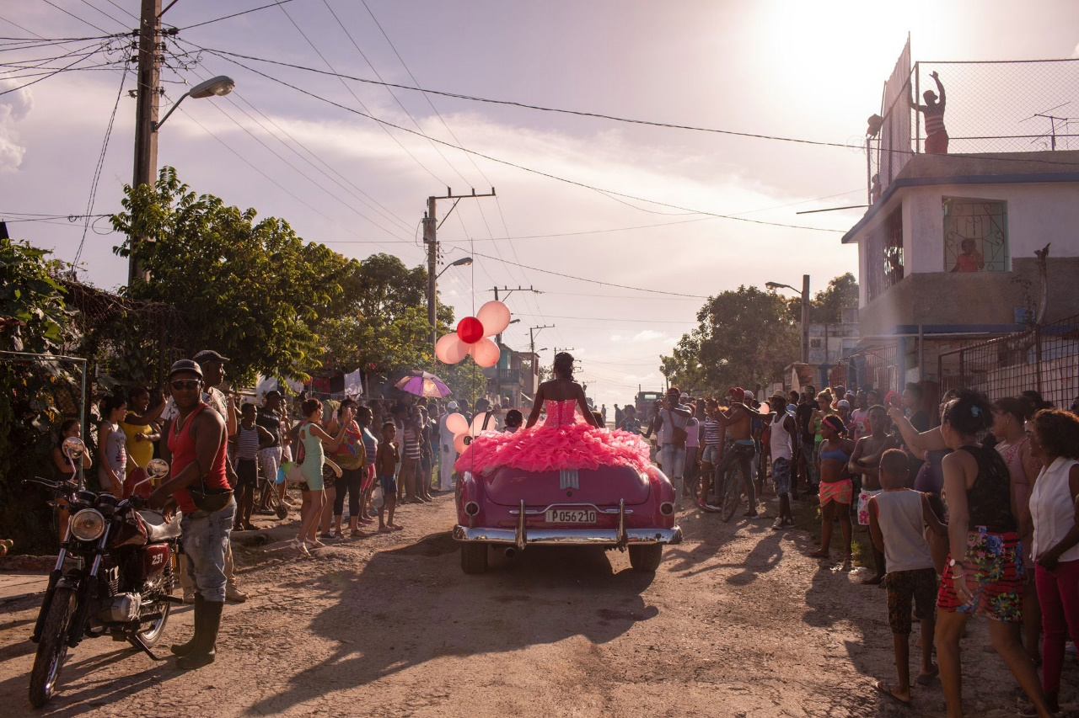
Fotograf: Diana Markosian, 2018
Din tekst:

Assignment 3
Udfyld tabellerne nedenfor.

Fifteen years after the Kardashians first aired, it is curious to consider the evolution of the format, and the psychology of those who take part in it.
(…)
Unlike TV talent shows, which prey on the genuinely desperate, it is hard to see much exploitation here, beyond something very broad about what happens when interior life is scooped out by Instagram fame. A theme of the show is authenticity, and the Byron Bay locals like to distinguish themselves from people from, for example, the Gold Coast, who are disparaged for having “spray-on dresses and fake lips”. With many lumbering cues, the show’s audience is invited to consider that Gold Coasters, with their tans and tiny dresses, live a more authentic existence than the parade of shallow oddballs in Byron Bay.
Each character has, very obviously, made the calculation that exposure and the opportunities that come with it are worth the cost of derision. Elle throws a fundraiser to draw attention to the destruction of ocean life, at which she serves tuna canapés and is delivered cleanly to the audience on a plate. Jade, who presents like a creation of Sacha Baron Cohen’s, is exposed for allegedly buying his Instagram followers in Turkey.
Emma Brockes, “Netflix’s Byron Baes is contrived, trashy and awful. It’s practically a public service”

Find og skriv tre forskellige måder, hvorpå der i teksten udtrykkes ejerskab, enten ved brug af genitiv eller pronomener.
1. eksempel
2. eksempel
3. eksempel

Find tre forskellige relative pronomener i teksten, og angiv, om de indleder en parentetisk eller en definerende/bestemmende relativsætning.
 | Dit valgte relative pronomen | Parentetisk eller  definerende/bestemmende  relativsætning?
1. eksempel
2. eksempel
3. eksempel

Find og angiv henholdsvis hovedsætning og ledsætning i nedenstående sætning.
Fifteen years after the Kardashians first aired, it is curious to consider the evolution
of the format.

Hovedsætning:

Ledsætning:

Assignment 4 (Word count: 800-1200 words)
Answer either assignment 4A or assignment 4B

Word count:

